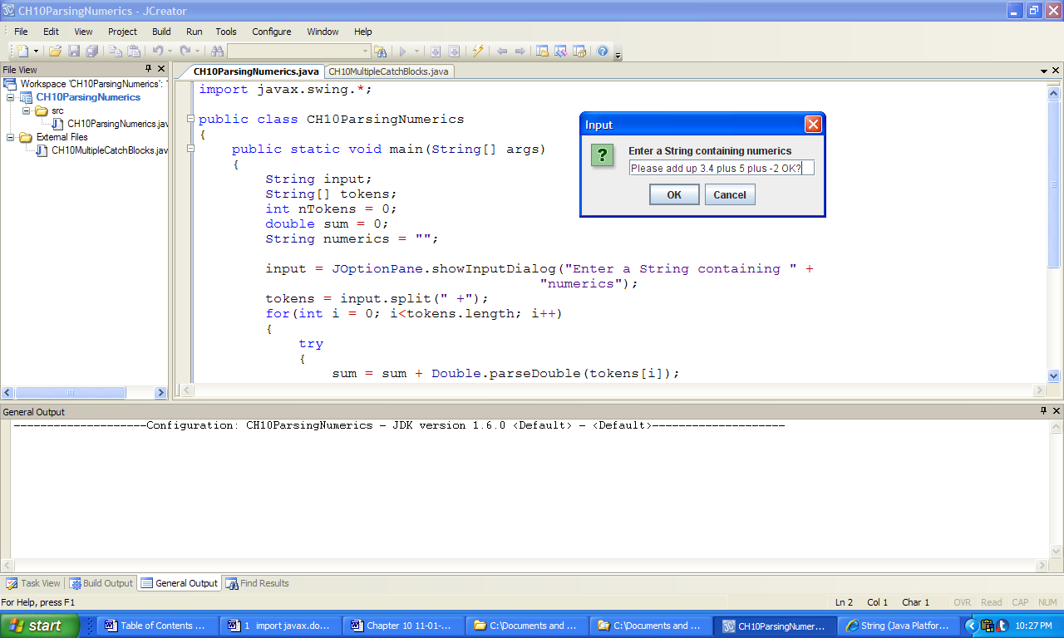 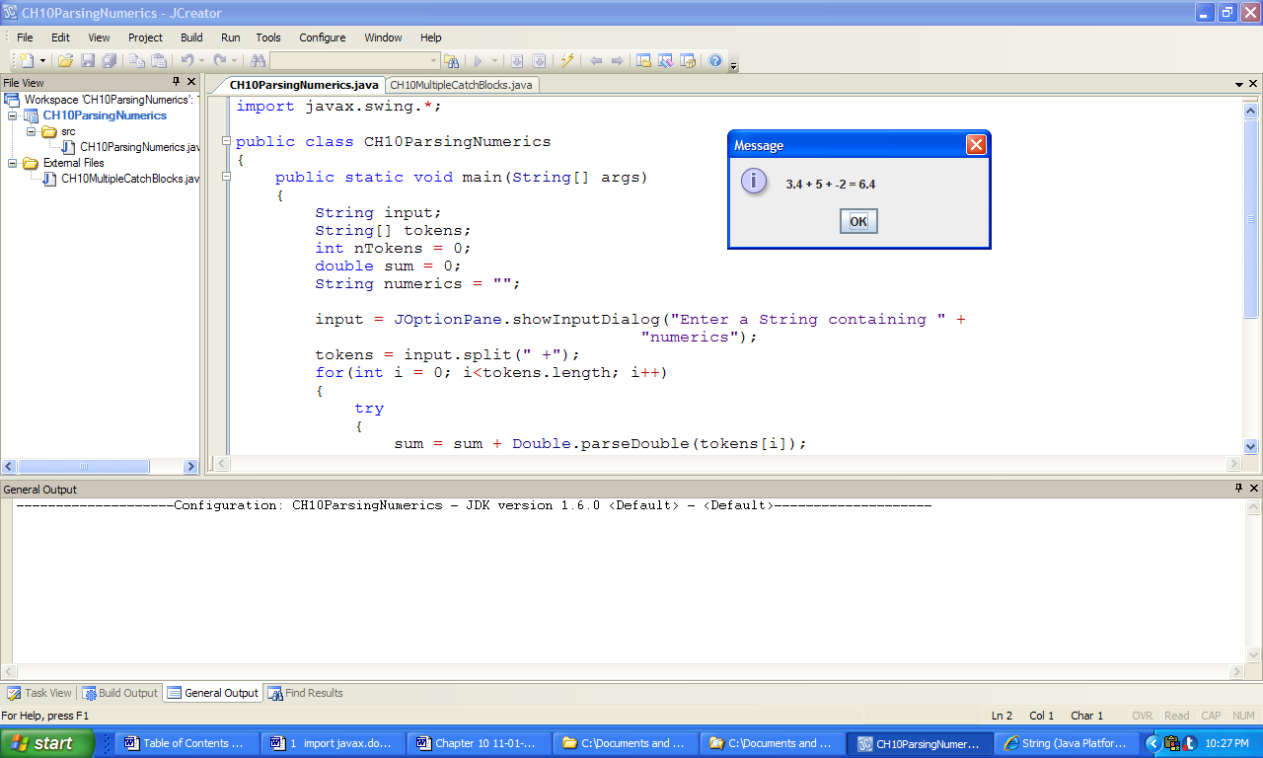

**Figure 10.9 An input to application ParsingNumerics and the resulting output.**